DevOps Assignment
Deploy a Multi-Service Node.js E-commerce Application Using Terraform and Docker
AWS EC2 | Docker Hub | Terraform
Field | Details
Submitted by | Saurabh Bhatnagar
Course / Program | ______Batch16A______________
Platform | HeroVired Virtual Education (HeroX)
Date | October 17, 2026
GitHub Repository | ___ https://github.com/srvbhtngr1/Ecommerce-terraform-docker-Skill-Test-3_________________
Docker Hub Profile | ____ https://hub.docker.com/repositories/srvbhtngr1________________

Table of Contents
Table of Contents 1
1. Introduction and Objective 1
1.1 Problem statement 1
1.2 What was delivered 1
1.3 Marks distribution 1
2. Solution Architecture 1
2.1 Services and ports 1
2.2 Design decisions 1
3. Prerequisites and Environment Setup 1
3.1 Tools required 1
3.2 Step 1: Verify the installations 1
3.3 Step 2: Configure AWS credentials 1
3.4 Step 3: Log in to Docker Hub 1
4. Part 1: Application Setup (Manual) 1
4.1 Step 4: Create the project structure 1
4.2 Step 5: Write the backend services 1
4.3 Step 6: Write the frontend 1
4.4 Step 7: Write the Dockerfiles 1
4.5 Step 8: Build and test the images locally 1
4.6 Step 9: Tag and push the images to Docker Hub 1
5. Part 2: Infrastructure Provisioning with Terraform 1
5.1 Step 10: Provider configuration 1
5.2 Step 11: Input variables 1
5.3 Step 12: Networking, security group and EC2 (main.tf) 1
5.4 Step 13: User-data script (Docker install and container start) 1
5.5 Step 14: Outputs 1
5.6 Step 15: Provide your values 1
5.7 Step 16: Initialise, validate, plan and apply 1
5.8 Step 17: Verify the infrastructure in the AWS console 1
6. Part 3: Deployment and Accessibility 1
6.1 Step 18: Open the frontend 1
6.2 Step 19: Verify the containers on the instance 1
6.3 Optional: confirm backends are not public 1
7. Evaluation Criteria Mapping 1
7.1 Requirement checklist 1
8. Troubleshooting Guide 1
9. Challenges Faced and Learnings 1
9.1 Possible improvements 1
10. Cleanup 1
11. Conclusion 1
Appendix A: Command Reference 1

1. Introduction and Objective
This report documents the complete, step-by-step implementation of a multi-service Node.js e-commerce application that is containerized with Docker and deployed on Amazon Web Services (AWS) using Terraform. The work was carried out by Saurabh Bhatnagar as part of the DevOps assignment "Deploy a Multi-Service Node.js E-commerce Application Using Terraform and Docker".

1.1 Problem statement
The application consists of four backend services (user, products, orders and cart) and one frontend. Each service must be containerized, its image published to Docker Hub, and all five containers deployed on an AWS EC2 instance that is provisioned entirely by Terraform. The frontend has to be publicly reachable, and Terraform must print the public IP or DNS of the application.

1.2 What was delivered
- Five Node.js services, each with its own Dockerfile, built and tested locally.
- Five public images pushed to Docker Hub.
- A Terraform configuration that creates a VPC, public subnet, internet gateway, route table, security group and an Ubuntu 22.04 EC2 instance.
- A user-data script that installs Docker, pulls the five images and runs them on the correct ports.
- A public frontend page showing "Frontend is Live" together with the live status of all four backends.
- Terraform outputs for the public IP, public DNS and the frontend URL.
- This documentation, with screenshots as evidence for every major step.

1.3 Marks distribution
Component | Marks
VPC, subnet and security group setup | 10
EC2 provisioning with Docker setup | 10
Docker container deployment via user-data or provisioners | 10
Public access to frontend | 10
Documentation | 10
Total | 50

2. Solution Architecture
A single Ubuntu 22.04 EC2 instance runs in a public subnet of a custom VPC. An internet gateway and route table provide internet access, which the instance needs to download Docker and pull images from Docker Hub. All five containers are attached to one user-defined Docker bridge network called ecom-net. On a user-defined network Docker provides DNS-based name resolution, so the frontend can call the backends using names such as http://user-service:3001 without hard-coding IP addresses.
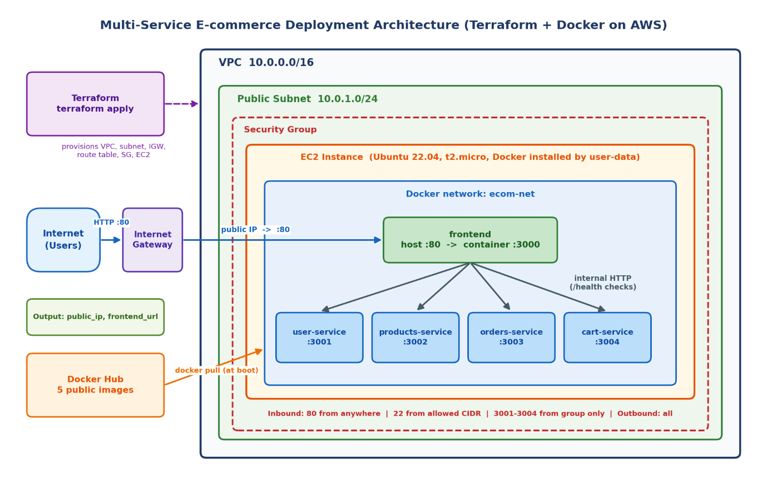
Architecture diagram: Internet, Internet Gateway, VPC (10.0.0.0/16), public subnet (10.0.1.0/24), EC2 instance, security group and five containers
Figure 1: Architecture diagram: Internet, Internet Gateway, VPC (10.0.0.0/16), public subnet (10.0.1.0/24), EC2 instance, security group and five containers

2.1 Services and ports
Service | Container name | Container port | Host port | Exposure
Frontend | frontend | 3000 | 80 | Public (HTTP)
User | user-service | 3001 | 3001 | Internal only
Products | products-service | 3002 | 3002 | Internal only
Orders | orders-service | 3003 | 3003 | Internal only
Cart | cart-service | 3004 | 3004 | Internal only

2.2 Design decisions
- Single EC2 instance: the assignment allows one or more instances; one instance keeps the setup simple and fits the 1-hour limit.
- Custom VPC: the requirement asks for a VPC with at least one public subnet, so the network is created explicitly rather than relying on the default VPC.
- Frontend on port 80: the container listens on 3000 and is mapped to host port 80 so the site opens with a plain http://<ip> URL.
- Backends not public: ports 3001-3004 are allowed only from the security group itself, so the backends are reachable between services but not from the internet.
- No third-party npm packages: the services use only built-in Node.js modules, which makes the images small and the build fast and reliable.
- Dynamic AMI lookup: a Terraform data source finds the latest Canonical Ubuntu 22.04 AMI, so the code works in any region without editing an AMI ID.

3. Prerequisites and Environment Setup

3.1 Tools required
Tool | Version | Purpose
Node.js (optional locally) | 18 or later | Run services without Docker for quick checks
Docker Desktop / Engine | 20.x or later | Build, test and push images
Terraform | 1.5 or later | Provision AWS infrastructure
AWS CLI | v2 | Configure credentials
Git (optional) | Any | Version control and submission
Docker Hub account | - | Host the five public images
AWS account + IAM user | - | Access keys with EC2 and VPC permissions

3.2 Step 1: Verify the installations
Open a terminal and confirm that every tool is installed.
Command
docker --version
terraform -version
aws --version
node --version

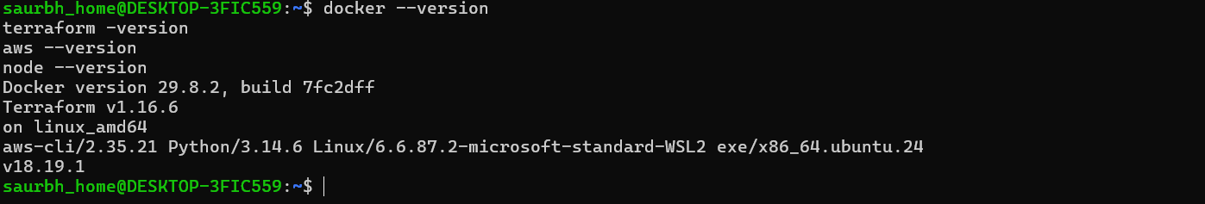Terminal showing docker, terraform, aws and node versions
Figure 2: Terminal showing docker, terraform, aws and node versions

3.3 Step 2: Configure AWS credentials
- In the AWS console open IAM, create a user (for example terraform-user) and attach permissions for EC2 and VPC (AmazonEC2FullAccess is sufficient for this assignment).
- Create an access key for the user and note the Access Key ID and Secret Access Key.
- Run aws configure and enter the keys, a default region (for example ap-south-1) and json as the output format.
- Verify the identity with aws sts get-caller-identity.
Command
aws configure
aws sts get-caller-identity

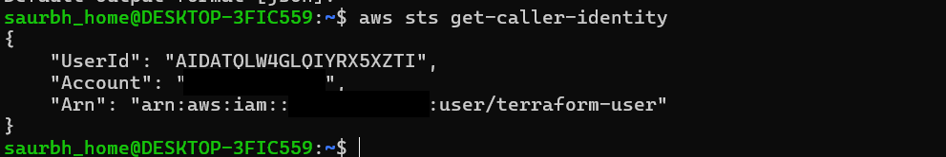aws sts get-caller-identity output (hide or blur the account ID if required)
Figure 3: aws sts get-caller-identity output (hide or blur the account ID if required)

3.4 Step 3: Log in to Docker Hub
Command
docker login

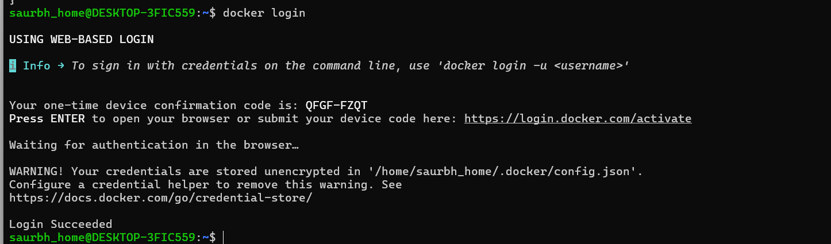docker login showing "Login Succeeded"
Figure 4: docker login showing "Login Succeeded"

4. Part 1: Application Setup (Manual)
This part is done manually, as required by the assignment, and covers writing the services, containerizing them, testing locally and publishing the images.

4.1 Step 4: Create the project structure
Commands
mkdir -p ecommerce-terraform-docker/services ecommerce-terraform-docker/terraform
cd ecommerce-terraform-docker
mkdir -p services/user-service services/products-service services/orders-service services/cart-service services/frontend

Final layout
ecommerce-terraform-docker/
|-- services/
| |-- user-service/ (server.js, package.json, Dockerfile, .dockerignore)
| |-- products-service/
| |-- orders-service/
| |-- cart-service/
| `-- frontend/
|-- terraform/
| |-- providers.tf variables.tf main.tf outputs.tf
| |-- user_data.sh.tpl
| `-- terraform.tfvars.example
|-- docker-compose.yml
|-- build_and_push.sh
`-- README.md

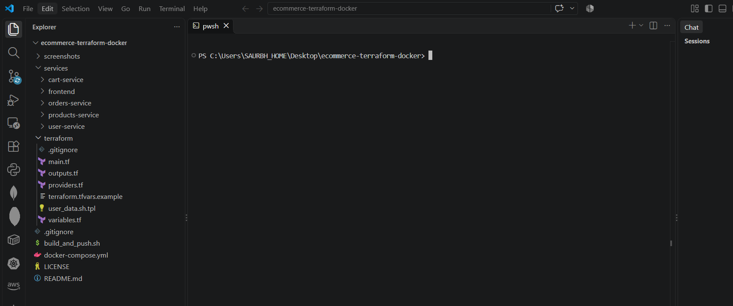Project folder structure in VS Code Explorer
Figure 5: Project folder structure in VS Code Explorer

4.2 Step 5: Write the backend services
Each backend is a small HTTP server written with the built-in http module. It listens on its own port, answers on / with a JSON message such as "user Service Running", and exposes /health, which the frontend uses to check whether the service is up. The four backends are identical except for the service name and port, shown here for the user service.
services/user-service/server.js
const http = require('http');
const PORT = process.env.PORT || 3001;
const NAME = 'user';

const server = http.createServer((req, res) => {
res.setHeader('Content-Type', 'application/json');
if (req.url === '/health') {
res.end(JSON.stringify({ service: NAME, status: 'UP', uptime: process.uptime() }));
} else {
res.end(JSON.stringify({ message: NAME + ' Service Running', port: Number(PORT) }));
}
});

server.listen(PORT, '0.0.0.0', () => console.log(NAME + ' Service Running on port ' + PORT));

services/user-service/package.json
{
"name": "user-service",
"version": "1.0.0",
"description": "user microservice for the e-commerce demo",
"main": "server.js",
"scripts": { "start": "node server.js" },
"license": "MIT"
}

The other three services are created the same way with these values:
Service | NAME constant | Default port | Response on /
user-service | user | 3001 | user Service Running
products-service | products | 3002 | products Service Running
orders-service | orders | 3003 | orders Service Running
cart-service | cart | 3004 | cart Service Running

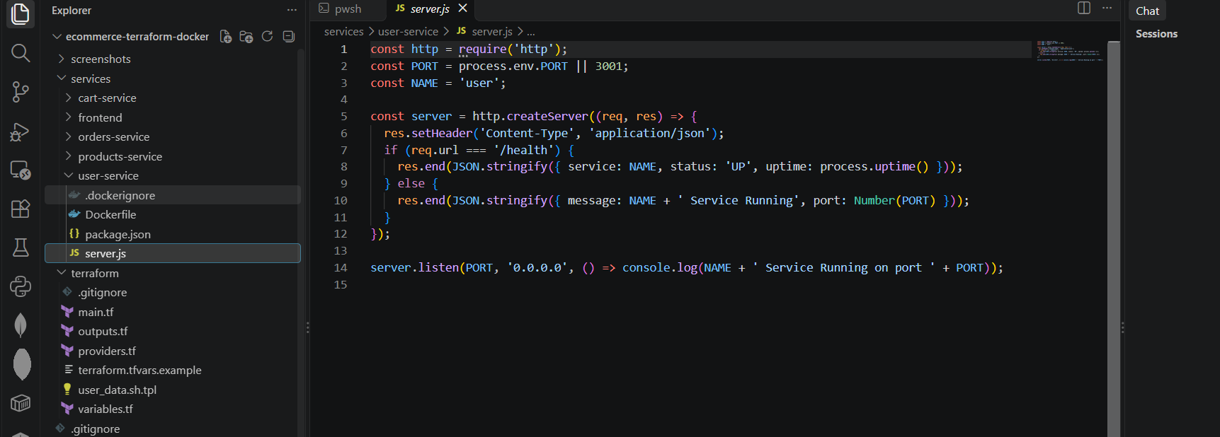server.js of one backend service open in the editor
Figure 6: server.js of one backend service open in the editor

4.3 Step 6: Write the frontend
The frontend serves an HTML page with the heading "Frontend is Live". A small script on the page calls /api/status. The frontend server answers that call by requesting /health from each backend over the Docker network and returning UP or DOWN for each one. This gives a visual proof in the browser that all backend containers are running and can talk to each other.
services/frontend/server.js
const http = require('http');
const PORT = process.env.PORT || 3000;
const SERVICES = {
user: process.env.USER_URL || 'http://user-service:3001',
products: process.env.PRODUCTS_URL || 'http://products-service:3002',
orders: process.env.ORDERS_URL || 'http://orders-service:3003',
cart: process.env.CART_URL || 'http://cart-service:3004',
};

async function status() {
const out = {};
await Promise.all(Object.entries(SERVICES).map(async ([name, url]) => {
try {
const r = await fetch(url + '/health', { signal: AbortSignal.timeout(2000) });
out[name] = r.ok ? 'UP' : 'DOWN';
} catch (e) { out[name] = 'DOWN'; }
}));
return out;
}

const page = `<!DOCTYPE html>
<html><head><meta charset="utf-8"><title>E-commerce Frontend</title>
<style>
body{font-family:Arial,sans-serif;max-width:640px;margin:60px auto;text-align:center}
h1{color:#1a7f37} li{list-style:none;margin:8px 0;font-size:18px}
.UP{color:#1a7f37;font-weight:bold}.DOWN{color:#c62828;font-weight:bold}
</style></head><body>
<h1>Frontend is Live</h1>
<p>Multi-service e-commerce app deployed with Terraform and Docker</p>
<h3>Backend services</h3><ul id="s"><li>Checking...</li></ul>
<script>
fetch('/api/status').then(r=>r.json()).then(d=>{
document.getElementById('s').innerHTML = Object.entries(d)
.map(([k,v])=>'<li>'+k+' service: <span class="'+v+'">'+v+'</span></li>').join('');
});
</script></body></html>`;

http.createServer(async (req, res) => {
if (req.url === '/api/status') {
res.setHeader('Content-Type', 'application/json');
res.end(JSON.stringify(await status()));
} else if (req.url === '/health') {
res.setHeader('Content-Type', 'application/json');
res.end(JSON.stringify({ service: 'frontend', status: 'UP' }));
} else {
res.setHeader('Content-Type', 'text/html');
res.end(page);
}
}).listen(PORT, '0.0.0.0', () => console.log('Frontend is Live on port ' + PORT));

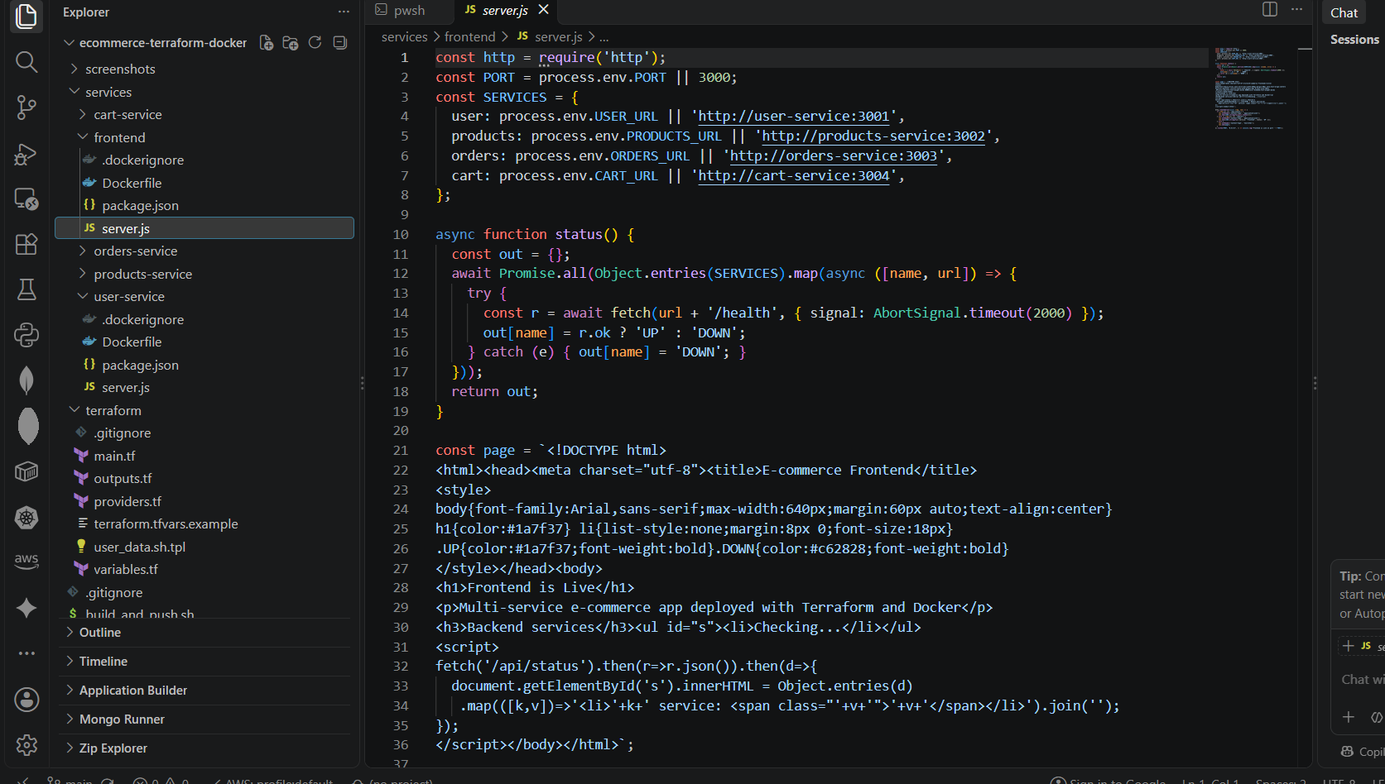frontend/server.js open in the editor
Figure 7: frontend/server.js open in the editor

4.4 Step 7: Write the Dockerfiles
Every service uses the same small Dockerfile based on node:18-alpine. Only the port differs. The frontend uses port 3000.
services/user-service/Dockerfile
FROM node:18-alpine
WORKDIR /app
COPY package.json ./
COPY server.js ./
ENV PORT=3001
EXPOSE 3001
CMD ["node", "server.js"]

services/frontend/Dockerfile
FROM node:18-alpine
WORKDIR /app
COPY package.json ./
COPY server.js ./
ENV PORT=3000
EXPOSE 3000
CMD ["node", "server.js"]

.dockerignore (same in every service)
node_modules
npm-debug.log
.git

Dockerfile instruction | Meaning
FROM node:18-alpine | Lightweight Node.js 18 base image (includes fetch, needed by the frontend)
WORKDIR /app | Working directory inside the container
COPY package.json / server.js | Copies the application files into the image
ENV PORT=... | Default port used by the server
EXPOSE ... | Documents the port the container listens on
CMD ["node", "server.js"] | Starts the service when the container runs

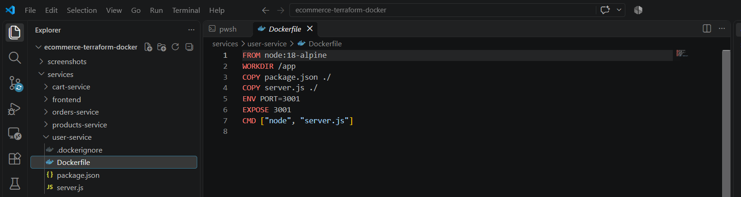
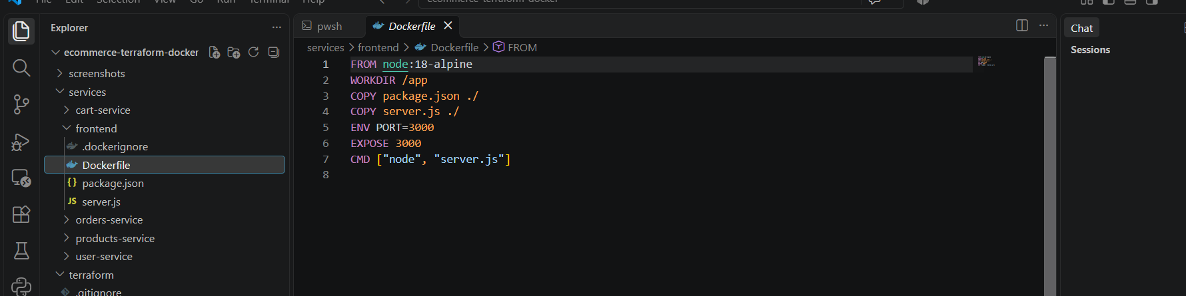
Dockerfile of one service and the frontend
Figure 8: Dockerfile of one service and the frontend

4.5 Step 8: Build and test the images locally
A docker-compose file is used only for local testing so that all five services can be started with one command.
docker-compose.yml
# Local testing only. Usage: docker compose up --build -d
services:
user-service:
build: ./services/user-service
container_name: user-service
ports: ["3001:3001"]
products-service:
build: ./services/products-service
container_name: products-service
ports: ["3002:3002"]
orders-service:
build: ./services/orders-service
container_name: orders-service
ports: ["3003:3003"]
cart-service:
build: ./services/cart-service
container_name: cart-service
ports: ["3004:3004"]
frontend:
build: ./services/frontend
container_name: frontend
ports: ["3000:3000"]
depends_on: [user-service, products-service, orders-service, cart-service]

Commands
docker compose up --build -d
docker ps

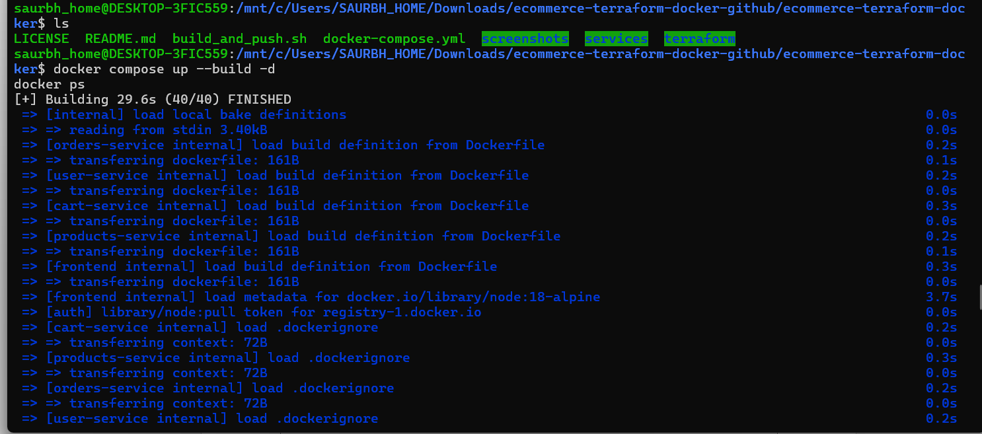Output of docker compose up --build (successful image builds)
Figure 9: Output of docker compose up --build (successful image builds)
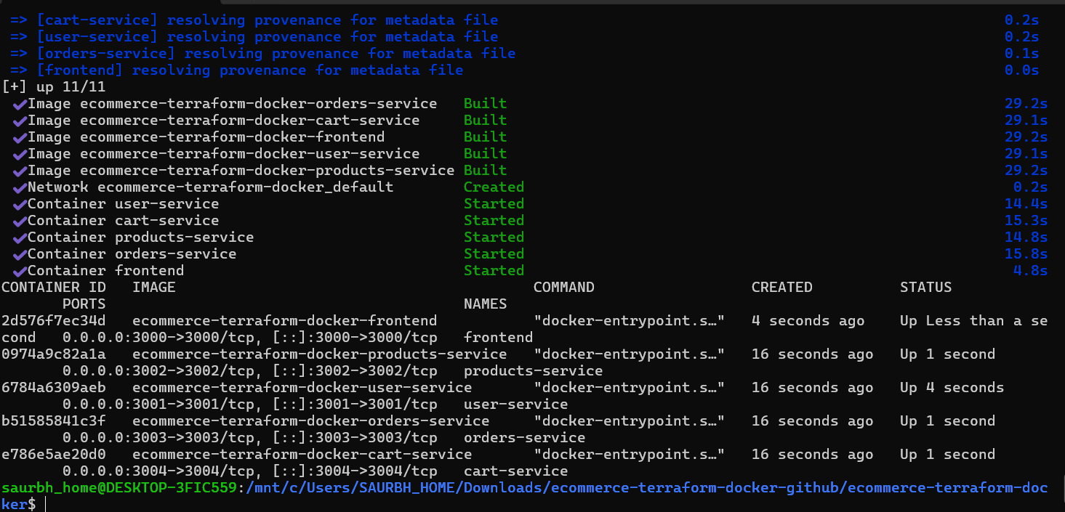docker ps showing all five containers running locally
Figure 10: docker ps showing all five containers running locally
Now test each service from the terminal and the browser:
Commands
curl http://localhost:3001
curl http://localhost:3002
curl http://localhost:3003
curl http://localhost:3004
curl http://localhost:3000/api/status

Expected output for the user service:
Expected response
{"message":"user Service Running","port":3001}

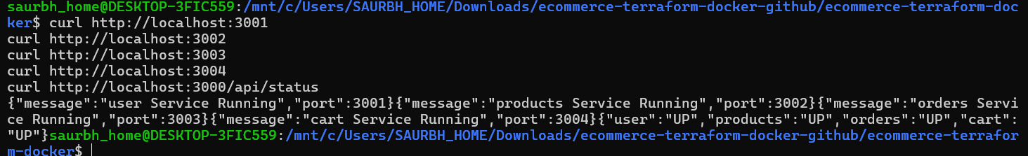curl responses from ports 3001 to 3004 showing "<name> Service Running"
Figure 11: curl responses from ports 3001 to 3004 showing "<name> Service Running"
Open http://localhost:3000 in a browser. The page should show "Frontend is Live" with all four backends marked UP.
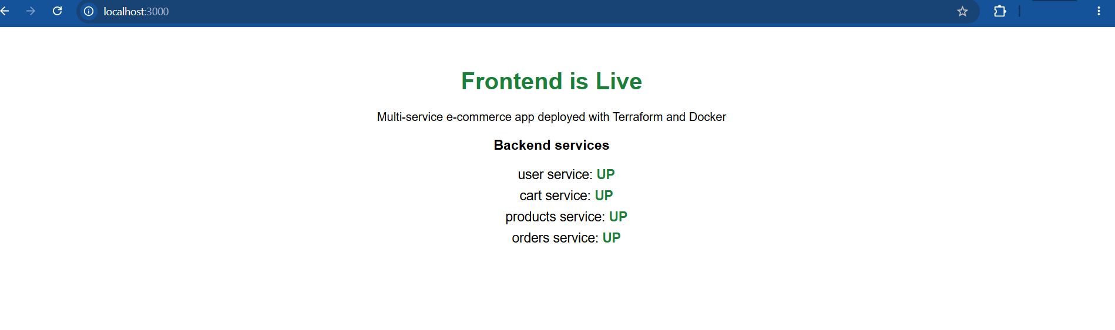Browser at http://localhost:3000 showing Frontend is Live and four services UP
Figure 12: Browser at http://localhost:3000 showing Frontend is Live and four services UP
When testing is complete, stop the local containers:
Command
docker compose down

4.6 Step 9: Tag and push the images to Docker Hub
The helper script builds each image with the tag <dockerhub-username>/<service>:latest and pushes it. Replace <dockerhub-username> with your own Docker Hub username.
build_and_push.sh
#!/usr/bin/env bash
# Usage: ./build_and_push.sh <dockerhub-username> [tag]
set -euo pipefail
USER_NAME="${1:?Usage: $0 <dockerhub-username> [tag]}"
TAG="${2:-latest}"
for svc in user-service products-service orders-service cart-service frontend; do
echo "==> Building and pushing $USER_NAME/$svc:$TAG"
docker build -t "$USER_NAME/$svc:$TAG" "services/$svc"
docker push "$USER_NAME/$svc:$TAG"
done
echo "All images pushed. Make each repo public on Docker Hub."

Commands
chmod +x build_and_push.sh
./build_and_push.sh <dockerhub-username>

The equivalent manual commands for one service are:
Manual equivalent
docker build -t <dockerhub-username>/user-service:latest services/user-service
docker push <dockerhub-username>/user-service:latest

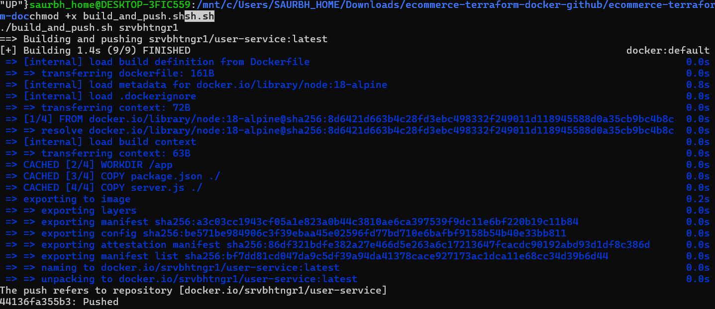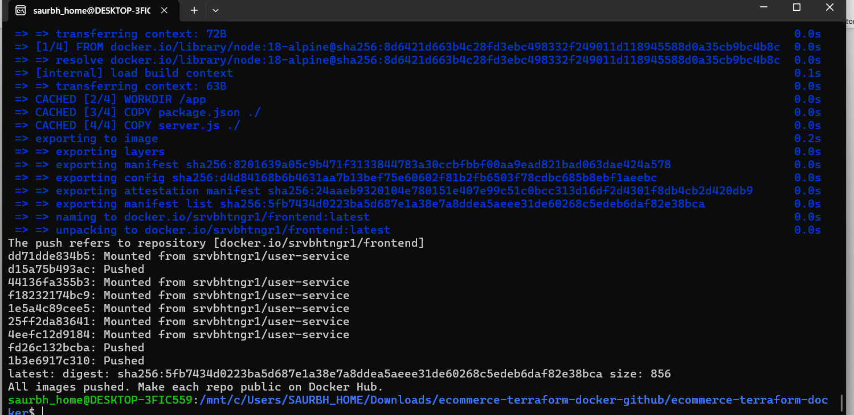
docker push output for the five images
Figure 13: docker push output for the five images
Important: Open each repository on Docker Hub and make sure its visibility is Public. The EC2 instance pulls the images without logging in, so private repositories would cause the deployment to fail.
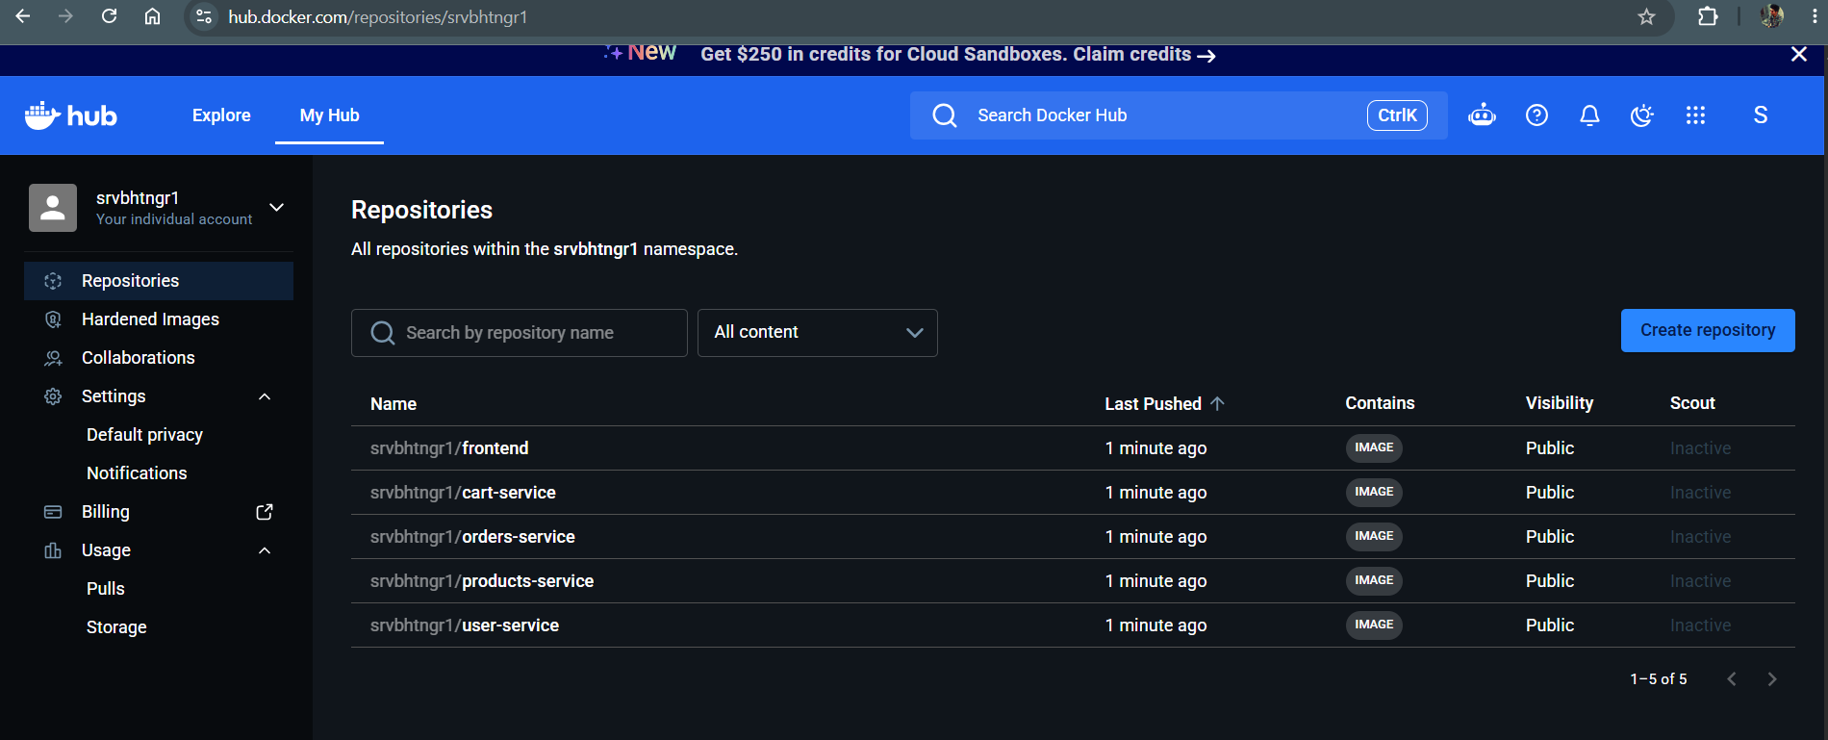Docker Hub repositories page listing all five public repositories
Figure 14: Docker Hub repositories page listing all five public repositories
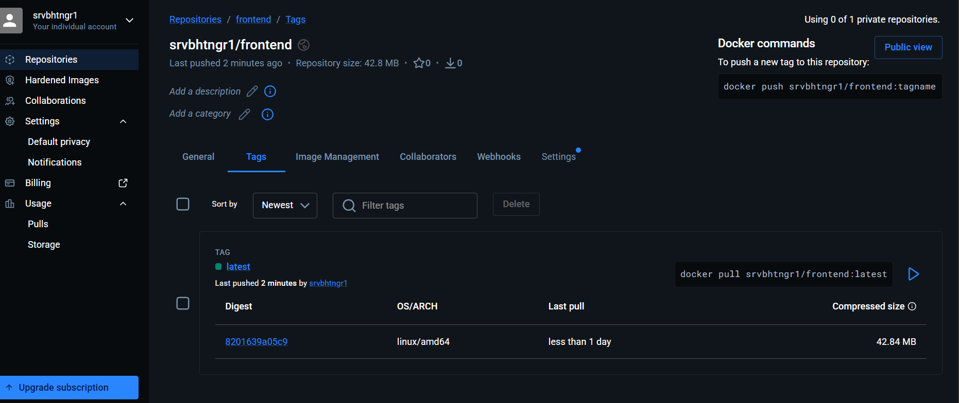One repository page on Docker Hub showing the latest tag
Figure 15: One repository page on Docker Hub showing the latest tag

5. Part 2: Infrastructure Provisioning with Terraform
All infrastructure is described in code under the terraform folder. The configuration is split into providers.tf, variables.tf, main.tf, outputs.tf and the user-data template.

5.1 Step 10: Provider configuration
terraform/providers.tf
terraform {
required_version = ">= 1.5.0"
required_providers {
aws = {
source = "hashicorp/aws"
version = "~> 5.0"
}
}
}

provider "aws" {
region = var.aws_region
}

This pins Terraform to version 1.5 or later and the AWS provider to version 5.x. The region is taken from a variable.

5.2 Step 11: Input variables
terraform/variables.tf
variable "aws_region" {
description = "AWS region to deploy into"
type = string
default = "ap-south-1"
}

variable "dockerhub_username" {
description = "Docker Hub username that owns the five public images"
type = string
}

variable "image_tag" {
description = "Docker image tag to deploy"
type = string
default = "latest"
}

variable "instance_type" {
description = "EC2 instance type"
type = string
default = "t2.micro"
}

variable "key_name" {
description = "Optional existing EC2 key pair name for SSH access (leave empty for none)"
type = string
default = ""
}

variable "allowed_ssh_cidr" {
description = "CIDR allowed to SSH (22). Use your IP, e.g. 203.0.113.10/32"
type = string
default = "0.0.0.0/0"
}

variable "project_name" {
description = "Prefix for resource names"
type = string
default = "ecommerce"
}

Variable | Default | Description
aws_region | ap-south-1 | Region for all resources
dockerhub_username | none (required) | Owner of the five public images
image_tag | latest | Image tag to deploy
instance_type | t2.micro | EC2 size (free-tier eligible in most regions)
key_name | "" (none) | Optional EC2 key pair for SSH
allowed_ssh_cidr | 0.0.0.0/0 | Who may SSH; restrict to your IP/32 for safety
project_name | ecommerce | Name prefix for resources

5.3 Step 12: Networking, security group and EC2 (main.tf)
main.tf creates the following resources, in dependency order:
- aws_vpc: VPC with CIDR 10.0.0.0/16 and DNS support and hostnames enabled.
- aws_internet_gateway: attaches an internet gateway to the VPC.
- aws_subnet: public subnet 10.0.1.0/24 with map_public_ip_on_launch enabled so the instance receives a public IP.
- aws_route_table and association: default route 0.0.0.0/0 through the internet gateway, associated with the public subnet.
- aws_security_group: ingress on 80 from anywhere, on 22 from allowed_ssh_cidr, and on 3001-3004 from the group itself; all egress allowed.
- aws_instance: Ubuntu 22.04 instance with the user-data script rendered by templatefile().
terraform/main.tf
# ---------- AMI: latest Ubuntu 22.04 LTS ----------
data "aws_ami" "ubuntu" {
most_recent = true
owners = ["099720109477"] # Canonical

filter {
name = "name"
values = ["ubuntu/images/hvm-ssd/ubuntu-jammy-22.04-amd64-server-*"]
}
filter {
name = "virtualization-type"
values = ["hvm"]
}
}

data "aws_availability_zones" "available" {
state = "available"
}

# ---------- Networking ----------
resource "aws_vpc" "main" {
cidr_block = "10.0.0.0/16"
enable_dns_support = true
enable_dns_hostnames = true

tags = { Name = "${var.project_name}-vpc" }
}

resource "aws_internet_gateway" "igw" {
vpc_id = aws_vpc.main.id
tags = { Name = "${var.project_name}-igw" }
}

resource "aws_subnet" "public" {
vpc_id = aws_vpc.main.id
cidr_block = "10.0.1.0/24"
availability_zone = data.aws_availability_zones.available.names[0]
map_public_ip_on_launch = true

tags = { Name = "${var.project_name}-public-subnet" }
}

resource "aws_route_table" "public" {
vpc_id = aws_vpc.main.id

route {
cidr_block = "0.0.0.0/0"
gateway_id = aws_internet_gateway.igw.id
}

tags = { Name = "${var.project_name}-public-rt" }
}

resource "aws_route_table_association" "public" {
subnet_id = aws_subnet.public.id
route_table_id = aws_route_table.public.id
}

# ---------- Security group ----------
resource "aws_security_group" "app" {
name = "${var.project_name}-sg"
description = "Frontend HTTP, SSH and internal service ports"
vpc_id = aws_vpc.main.id

ingress {
description = "HTTP to frontend"
from_port = 80
to_port = 80
protocol = "tcp"
cidr_blocks = ["0.0.0.0/0"]
}

ingress {
description = "SSH"
from_port = 22
to_port = 22
protocol = "tcp"
cidr_blocks = [var.allowed_ssh_cidr]
}

ingress {
description = "Internal service-to-service ports 3001-3004"
from_port = 3001
to_port = 3004
protocol = "tcp"
self = true
}

egress {
description = "Allow all outbound (Docker Hub, apt)"
from_port = 0
to_port = 0
protocol = "-1"
cidr_blocks = ["0.0.0.0/0"]
}

tags = { Name = "${var.project_name}-sg" }
}

# ---------- EC2 ----------
resource "aws_instance" "app" {
ami = data.aws_ami.ubuntu.id
instance_type = var.instance_type
subnet_id = aws_subnet.public.id
vpc_security_group_ids = [aws_security_group.app.id]
key_name = var.key_name != "" ? var.key_name : null

user_data = templatefile("${path.module}/user_data.sh.tpl", {
dockerhub_username = var.dockerhub_username
image_tag = var.image_tag
})
user_data_replace_on_change = true

root_block_device {
volume_size = 12
volume_type = "gp3"
}

tags = { Name = "${var.project_name}-app-server" }
}

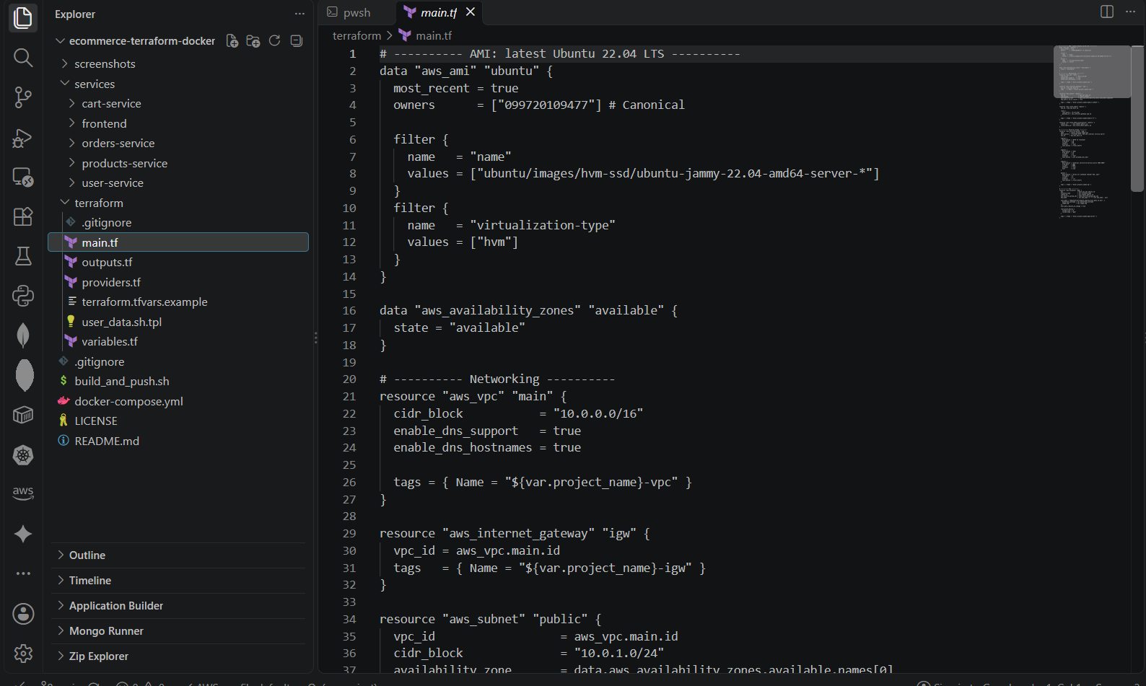 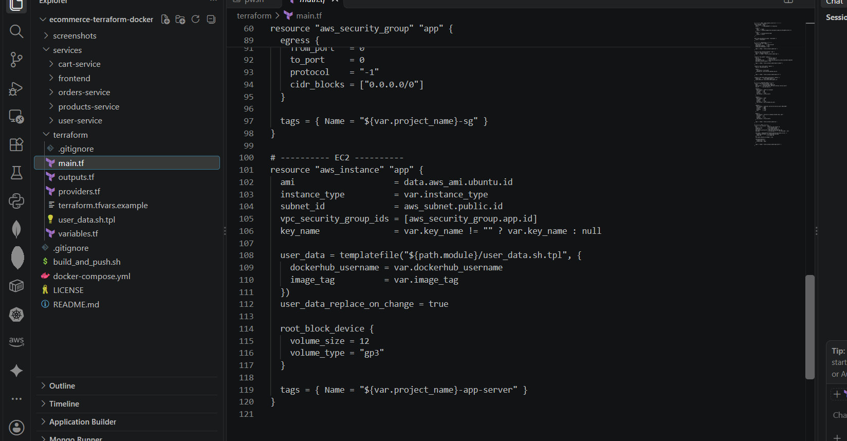main.tf open in the editor (networking and security group sections)
Figure 16: main.tf open in the editor (networking and security group sections)

Security group rules explained
Rule | Port(s) | Source | Reason
Inbound HTTP | 80 | 0.0.0.0/0 | Public access to the frontend
Inbound SSH | 22 | allowed_ssh_cidr | Administration and verification
Inbound custom TCP | 3001-3004 | The security group itself | Internal communication between services
Outbound | All | 0.0.0.0/0 | apt packages and Docker Hub image pulls

5.4 Step 13: User-data script (Docker install and container start)
The user-data script is executed once by cloud-init at first boot, as root. It installs Docker, creates the Docker network, pulls the five images and starts the containers with --restart always so they come back after a reboot. Terraform fills in the Docker Hub username and image tag through templatefile().
terraform/user_data.sh.tpl
#!/bin/bash
# Runs once at first boot. Log: /var/log/user-data.log
exec > >(tee /var/log/user-data.log) 2>&1
set -x

export DEBIAN_FRONTEND=noninteractive
apt-get update -y
apt-get install -y docker.io
systemctl enable --now docker

DH="${dockerhub_username}"
TAG="${image_tag}"

# User-defined network so containers resolve each other by name
docker network create ecom-net || true

# Pull all five images
for svc in user-service products-service orders-service cart-service frontend; do
docker pull "$DH/$svc:$TAG"
done

# Backends (published on host ports for local verification; SG blocks them from the internet)
docker run -d --name user-service --network ecom-net --restart always -p 3001:3001 "$DH/user-service:$TAG"
docker run -d --name products-service --network ecom-net --restart always -p 3002:3002 "$DH/products-service:$TAG"
docker run -d --name orders-service --network ecom-net --restart always -p 3003:3003 "$DH/orders-service:$TAG"
docker run -d --name cart-service --network ecom-net --restart always -p 3004:3004 "$DH/cart-service:$TAG"

# Frontend: host port 80 -> container port 3000
docker run -d --name frontend --network ecom-net --restart always -p 80:3000 "$DH/frontend:$TAG"

docker ps
echo "Deployment complete"

Script section | What it does
exec > >(tee /var/log/user-data.log) | Writes all output to /var/log/user-data.log for troubleshooting
apt-get install -y docker.io | Installs Docker from the Ubuntu repository
systemctl enable --now docker | Starts Docker now and on every boot
docker network create ecom-net | Creates the shared network for name-based service discovery
docker pull ... | Downloads all five images from Docker Hub
docker run -d --restart always ... | Starts each container in the background with the right port mapping
-p 80:3000 (frontend) | Publishes the frontend on the standard HTTP port

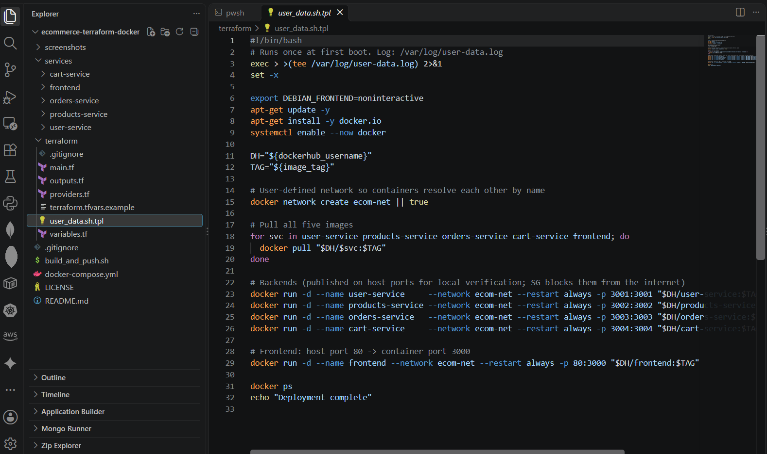user_data.sh.tpl open in the editor
Figure 17: user_data.sh.tpl open in the editor

5.5 Step 14: Outputs
terraform/outputs.tf
output "public_ip" {
description = "Public IP of the EC2 instance"
value = aws_instance.app.public_ip
}

output "public_dns" {
description = "Public DNS of the EC2 instance"
value = aws_instance.app.public_dns
}

output "frontend_url" {
description = "Open this URL to see the frontend (allow 2-3 minutes after apply)"
value = "http://${aws_instance.app.public_ip}"
}

After terraform apply, Terraform prints the instance public IP, public DNS and a ready-to-use frontend URL.

5.6 Step 15: Provide your values
Commands
cd terraform
cp terraform.tfvars.example terraform.tfvars

terraform.tfvars
dockerhub_username = "<your-dockerhub-username>"
aws_region = "ap-south-1"
# key_name = "my-key-pair"
# allowed_ssh_cidr = "<your-public-ip>/32"

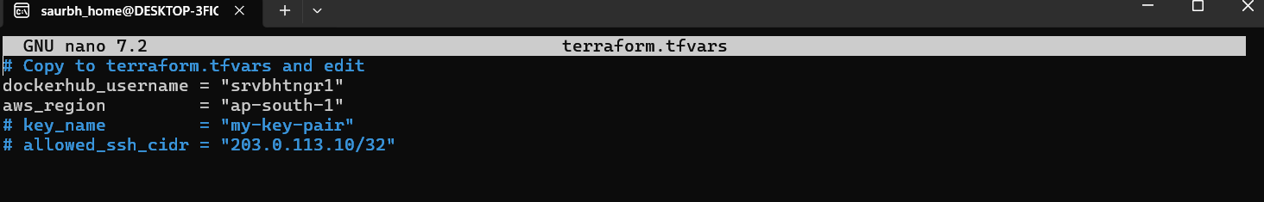terraform.tfvars with the Docker Hub username filled in
Figure 18: terraform.tfvars with the Docker Hub username filled in

5.7 Step 16: Initialise, validate, plan and apply
- terraform init: downloads the AWS provider and prepares the working directory.
- terraform fmt and validate: formats the code and checks that the configuration is syntactically valid.
- terraform plan: shows what will be created; expect 7 resources to add (VPC, internet gateway, subnet, route table, route table association, security group, EC2 instance).
- terraform apply: creates the resources after you type yes (or use -auto-approve).
Commands
terraform init
terraform fmt
terraform validate
terraform plan
terraform apply

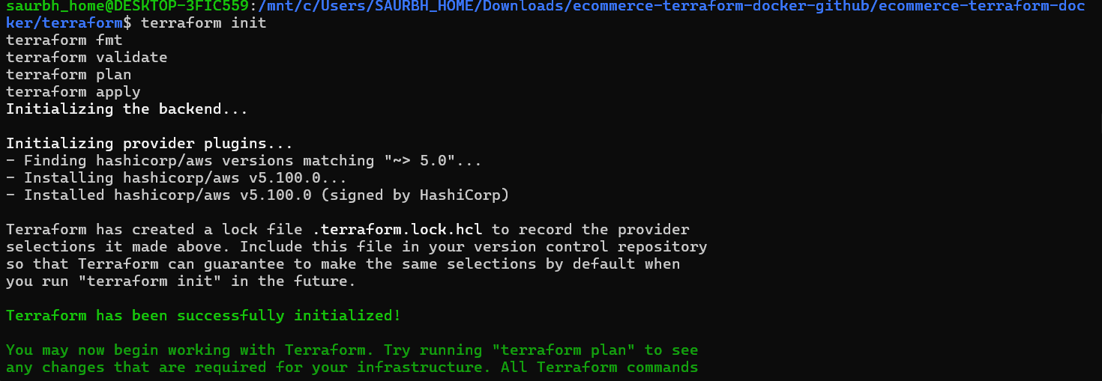terraform init completed successfully
Figure 19: terraform init completed successfully
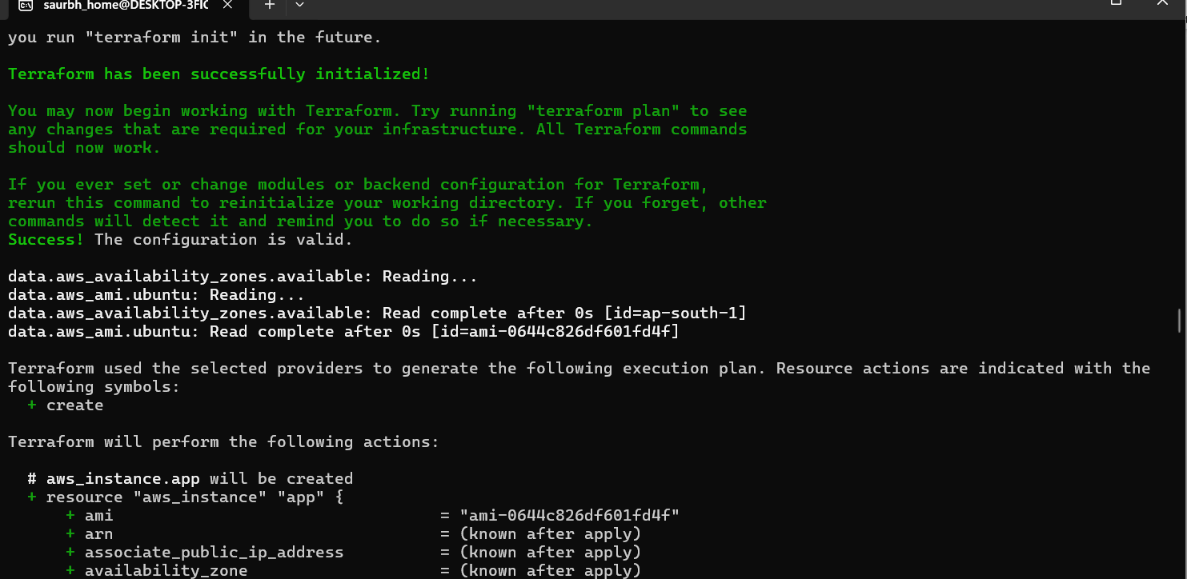terraform validate: Success! The configuration is valid
Figure 20: terraform validate: Success! The configuration is valid
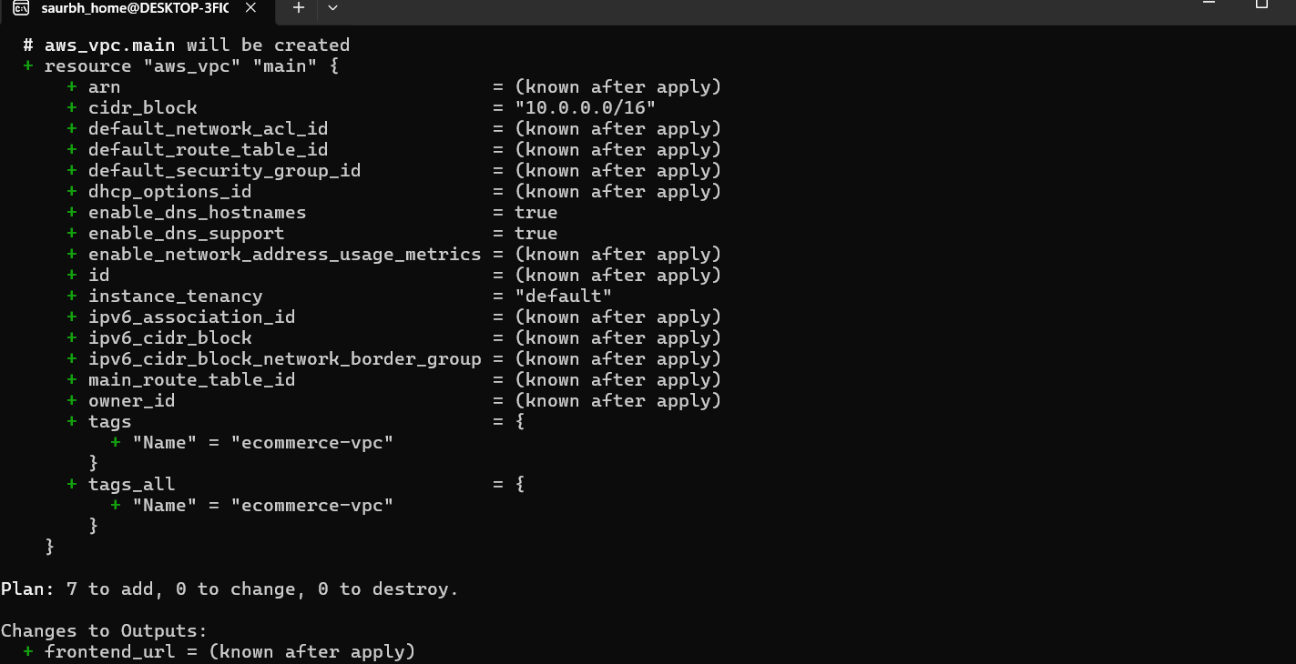terraform plan summary: Plan: 7 to add, 0 to change, 0 to destroy
Figure 21: terraform plan summary: Plan: 7 to add, 0 to change, 0 to destroy
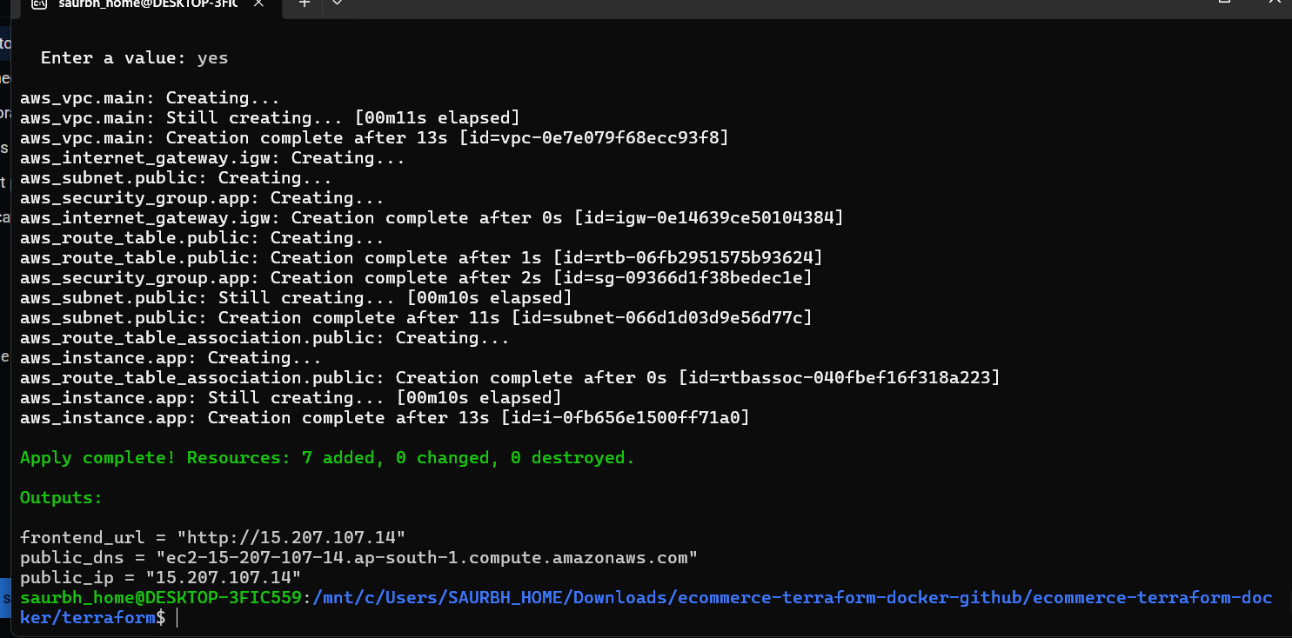terraform apply completed with Apply complete and the outputs (public_ip, public_dns, frontend_url)
Figure 22: terraform apply completed with Apply complete and the outputs (public_ip, public_dns, frontend_url)
Note: The exact number of resources shown in the plan can differ by one or two depending on provider defaults. Record whatever your own plan shows.

5.8 Step 17: Verify the infrastructure in the AWS console
- Open VPC > Your VPCs and find ecommerce-vpc (10.0.0.0/16).
- Open Subnets and confirm ecommerce-public-subnet (10.0.1.0/24) is attached to that VPC.
- Open Security Groups and confirm the inbound rules for ports 80, 22 and 3001-3004.
- Open EC2 > Instances and confirm ecommerce-app-server is Running with a public IPv4 address, and that status checks show 2/2 passed.
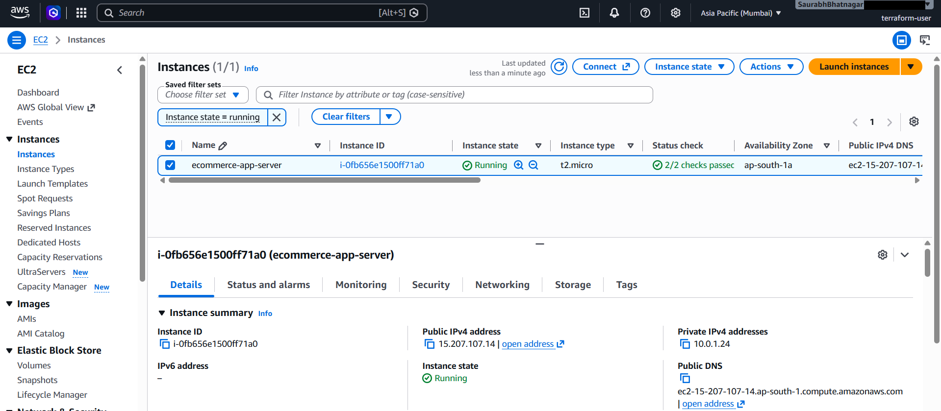
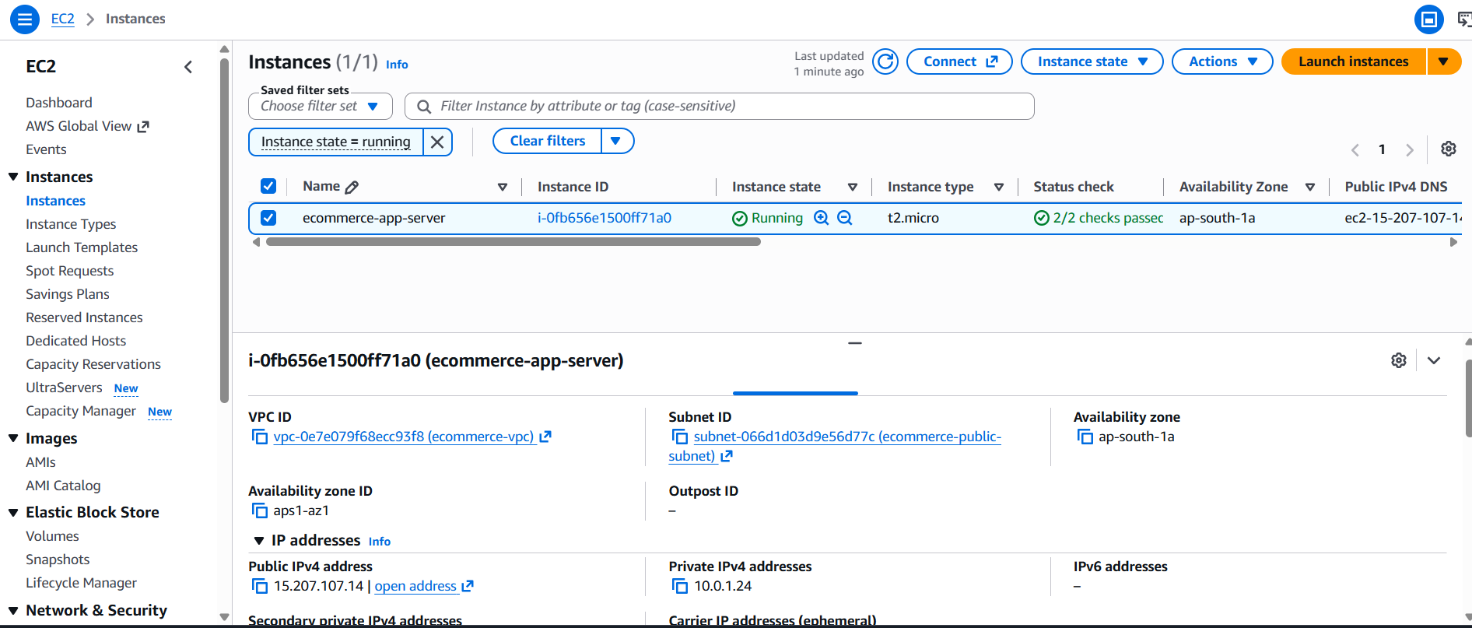VPC and subnet in the AWS VPC console
Figure 23: VPC and subnet in the AWS VPC console
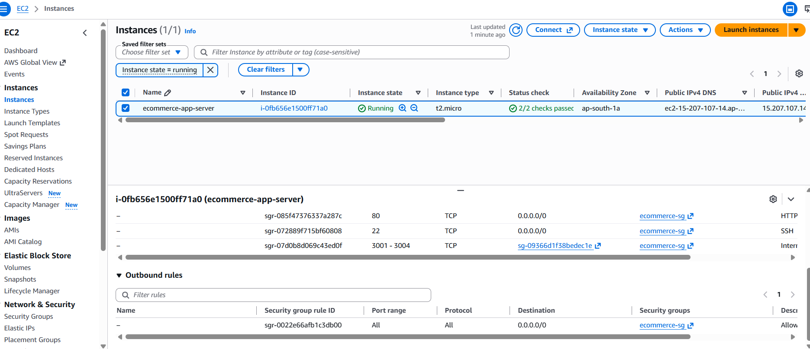Security group inbound rules: 80, 22 and 3001-3004 from the group itself
Figure 24: Security group inbound rules: 80, 22 and 3001-3004 from the group itself
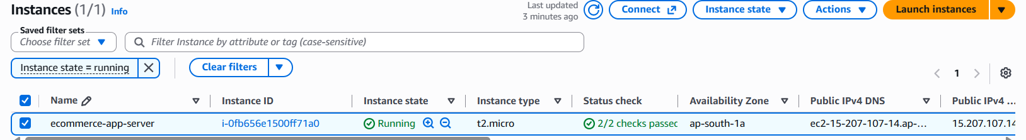EC2 instance in Running state with public IPv4 address and 2/2 status checks
Figure 25: EC2 instance in Running state with public IPv4 address and 2/2 status checks

6. Part 3: Deployment and Accessibility

6.1 Step 18: Open the frontend
cloud-init needs about 2 to 3 minutes after the instance starts to install Docker and pull the images. Then open the URL from the frontend_url output (or run terraform output frontend_url) in a browser.
Commands
terraform output
terraform output frontend_url

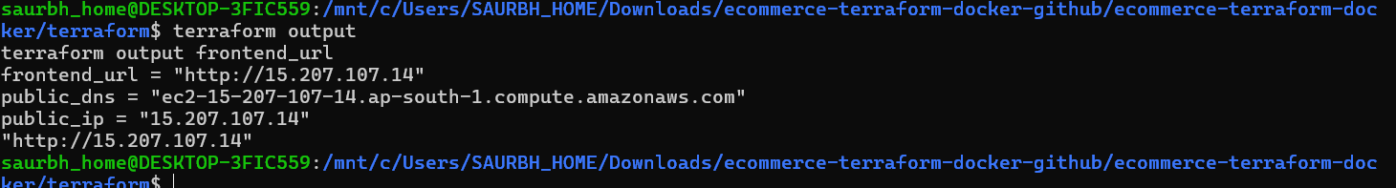terraform output showing public_ip, public_dns and frontend_url
Figure 26: terraform output showing public_ip, public_dns and frontend_url
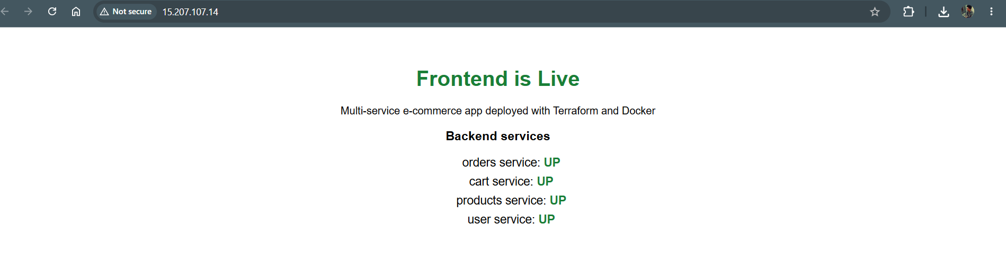Browser opened on the public IP showing the "Frontend is Live" page
Figure 27: Browser opened on the public IP showing the "Frontend is Live" page
The status list on the page shows each backend as UP, which proves that all four backend containers are running and reachable from the frontend over the Docker network.
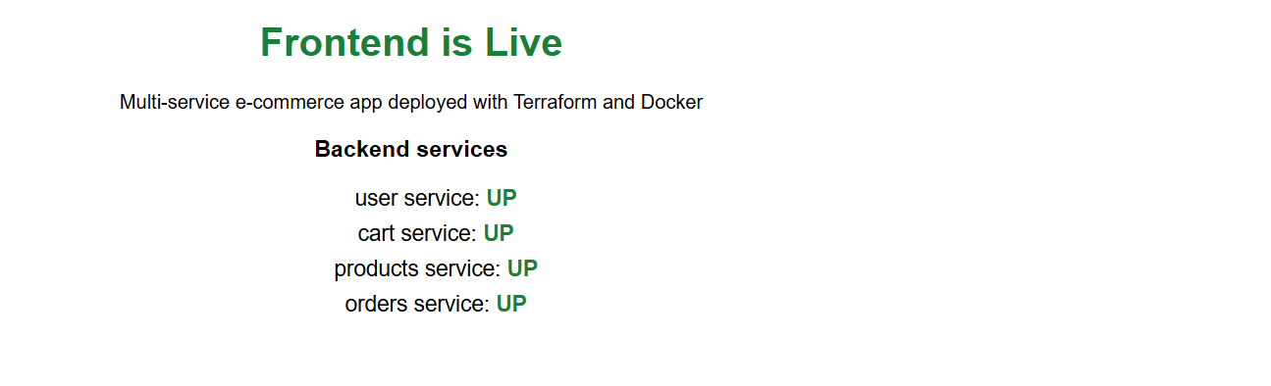Frontend page with user, products, orders and cart services all UP
Figure 28: Frontend page with user, products, orders and cart services all UP
Note: Figures 22 to 28 were captured on the first deployment (public IP 15.207.107.14). After correcting the key_name value in terraform.tfvars so that SSH access worked, Terraform replaced the EC2 instance, which received the new public IP 13.207.191.174. Figures 29 to 32 were captured on that second instance.

6.2 Step 19: Verify the containers on the instance
Connect to the instance over SSH (requires a key pair set in key_name) and check the containers directly.
Commands
ssh -i <your-key>.pem ubuntu@<public-ip>
docker ps
docker network inspect ecom-net

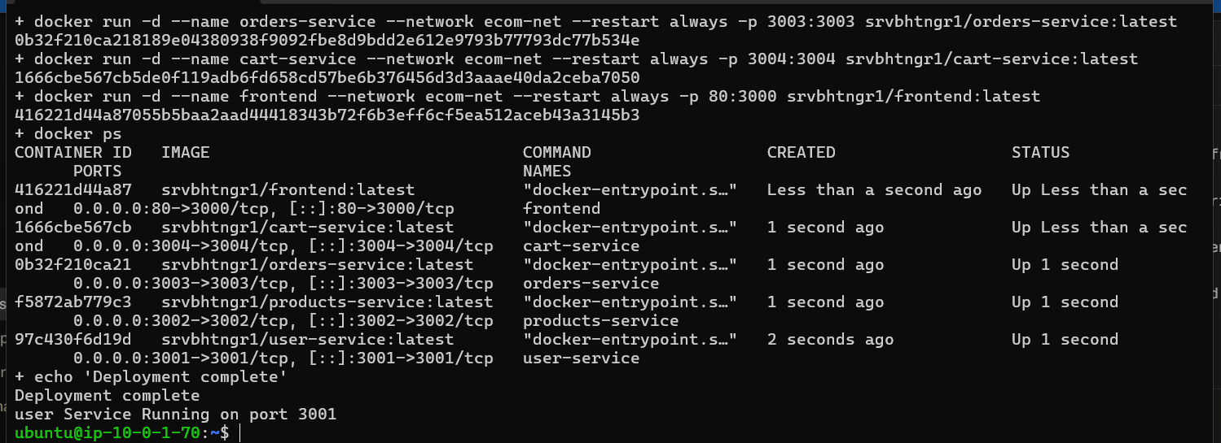docker ps on the EC2 instance showing frontend and four backend containers with status Up
Figure 29: docker ps on the EC2 instance showing frontend and four backend containers with status Up
Call each backend from the instance and review logs:
Commands
curl http://localhost:3001
curl http://localhost:3002
curl http://localhost:3003
curl http://localhost:3004/health
docker logs user-service
sudo tail -n 60 /var/log/user-data.log

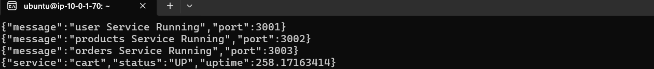 curl responses from the four backend services on the EC2 instance
Figure 30: curl responses from the four backend services on the EC2 instance
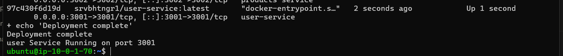 docker logs and /var/log/user-data.log showing "Deployment complete"
Figure 31: docker logs and /var/log/user-data.log showing "Deployment complete"

6.3 Optional: confirm backends are not public
From your own computer, a request to http://<public-ip>:3001 should time out because the security group only allows ports 3001-3004 from within the group. This demonstrates the intended least-privilege network design.
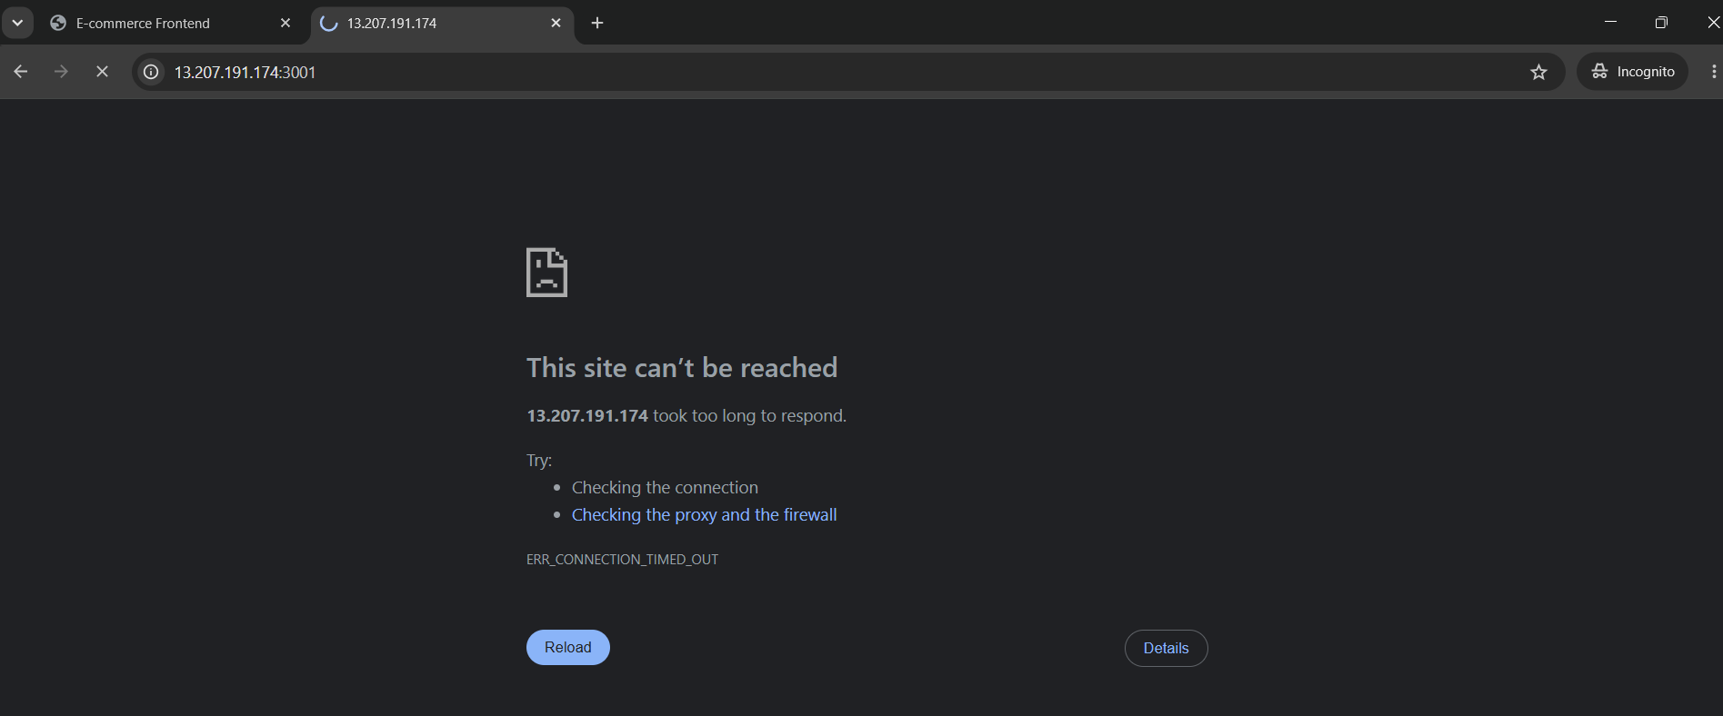 Browser or curl timing out on http://<public-ip>:3001 from outside
Figure 32: Browser or curl timing out on http://<public-ip>:3001 from outside

7. Evaluation Criteria Mapping
Component | Marks | Evidence in this report
VPC, subnet and security group setup | 10 | Sections 5.3 and 5.8; main.tf; console screenshots
EC2 provisioning with Docker setup | 10 | Sections 5.3, 5.4 and 5.7; user-data installs Docker; EC2 screenshot
Container deployment via user-data | 10 | Sections 5.4 and 6.2; docker ps and logs on the instance
Public access to frontend | 10 | Section 6.1; browser shows Frontend is Live on the public IP
Documentation | 10 | This complete step-by-step report with code and screenshots

7.1 Requirement checklist
Requirement | Status
Dockerfiles for all 5 services | Done
Each service returns a sample response | Done
Images built and tested locally | Done
Images tagged and pushed to Docker Hub | Done
VPC with at least one public subnet (Terraform) | Done
EC2 instance hosting the containers (Terraform) | Done
Security groups: HTTP to frontend and ports 3001-3004 internally | Done
Docker installed, images pulled, containers run via user-data | Done
Frontend publicly accessible with a "Frontend is Live" page | Done
Terraform output prints public IP / DNS | Done
Ubuntu 22.04 AMI | Done
Reproducible with terraform apply | Done

8. Troubleshooting Guide
Problem | Likely cause | Fix
Frontend page does not open right after apply | user-data still running | Wait 2-3 minutes; check /var/log/user-data.log
Frontend still not reachable | Security group or subnet routing | Confirm port 80 rule, public IP and route to the internet gateway
docker pull fails: pull access denied | Repository is private or username is wrong | Make repos public; verify dockerhub_username
Backends show DOWN on the page | Containers not on ecom-net or crashed | docker ps; docker logs <name>; docker network inspect ecom-net
terraform apply: UnauthorizedOperation | IAM user lacks permission | Attach AmazonEC2FullAccess (or equivalent)
terraform apply: InvalidKeyPair.NotFound | key_name does not exist in the region | Create the key pair in the same region or leave key_name empty
Changes to user-data not applied | Instance already booted | user_data_replace_on_change recreates the instance on terraform apply
SSH connection timed out | allowed_ssh_cidr does not include your IP | Update the variable to your current public IP/32

9. Challenges Faced and Learnings
Replace or extend the points below with your own experience while doing the assignment.
- Ordering of work: containers must be pushed to Docker Hub before Terraform runs, since the instance pulls them at boot.
- Timing: the application is not available immediately after terraform apply because user-data runs after the instance starts. Checking the log file made this clear.
- Networking: using a user-defined Docker network allowed container-name DNS, so no IP addresses had to be hard-coded.
- Security: restricting ports 3001-3004 to the security group itself keeps the backends private while the frontend stays public.
- Reproducibility: variables, a dynamic AMI lookup and a templated user-data script make the whole deployment repeatable with a single terraform apply.
- Personal challenge: ____________________________________________

9.1 Possible improvements
- Place backends on private subnets behind a NAT gateway and an Application Load Balancer.
- Store the Terraform state in S3 with DynamoDB locking.
- Use Amazon ECR instead of Docker Hub, and ECS or EKS instead of a single instance.
- Add HTTPS with a domain name and an ACM certificate.
- Add a CI/CD pipeline (GitHub Actions) to build, push and deploy automatically.

10. Cleanup
To avoid unnecessary AWS charges, destroy all resources once the work has been evaluated.
Command
cd terraform
terraform destroy

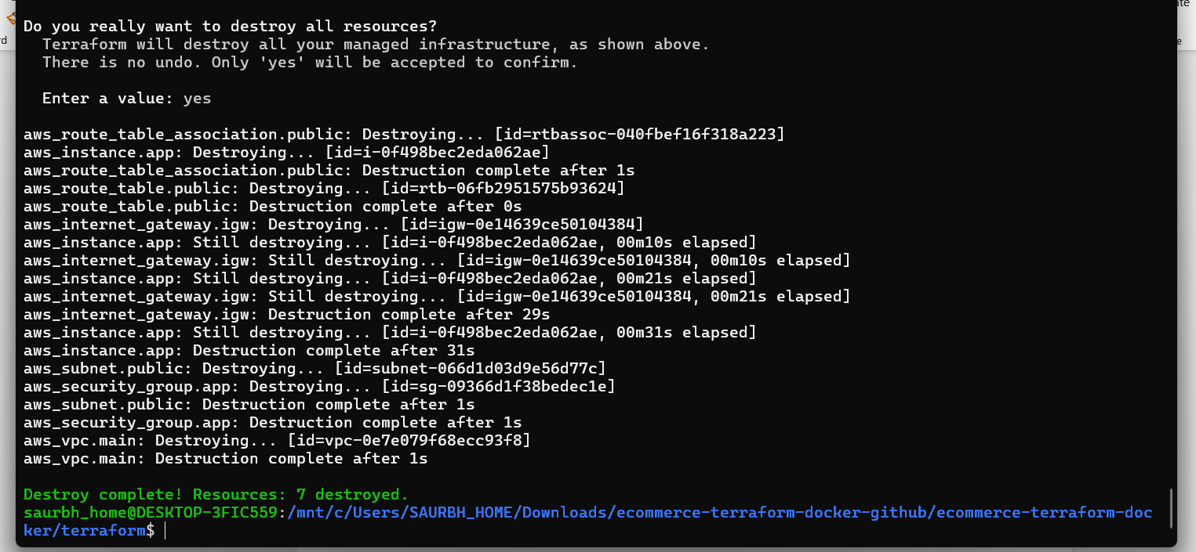terraform destroy completed: Destroy complete! Resources destroyed
Figure 33: terraform destroy completed: Destroy complete! Resources destroyed
Optionally confirm in the AWS console that the instance is terminated and the VPC is deleted.

11. Conclusion
All five services of the e-commerce application were containerized with Docker, tested locally and published to Docker Hub. Terraform then provisioned a VPC, public subnet, internet gateway, route table, security group and an Ubuntu EC2 instance, and a user-data script installed Docker and started every container on the right port. The frontend is publicly reachable through the public IP printed by Terraform and confirms the health of all backend services. The complete infrastructure can be created or destroyed with a single command, which demonstrates the main benefits of Infrastructure as Code and containerization.
Submitted by: Saurabh Bhatnagar

Appendix A: Command Reference
Task | Command
Start local stack | docker compose up --build -d
Stop local stack | docker compose down
Build and push all images | ./build_and_push.sh <dockerhub-username>
Initialise Terraform | terraform init
Preview changes | terraform plan
Create infrastructure | terraform apply
Show outputs | terraform output
Destroy infrastructure | terraform destroy
List containers on EC2 | docker ps
View container logs | docker logs <container-name>
View boot script log | sudo tail -n 60 /var/log/user-data.log

Total figures: 33.

